

**Asset Practice Answers: Mathematics**

1. On 5 th June, World Environment Day, five children planted saplings in a garden near their school. The number of saplings that each of them planted is shown in the pictograph:

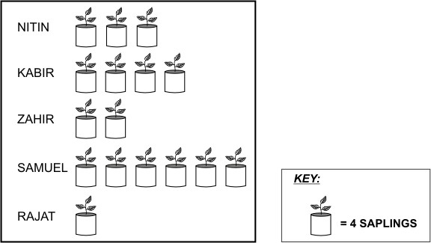

What is the total number of saplings planted by the five children?

A. 16

B. 20

C. 32

**D. 64**

2. Prabhu is using his broken scale to measure the length of a chalk stick.

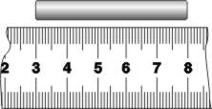

What is the length of the chalk stick? **A. 5 cm**

B. 6 cm

C. 8 cm

D. He cannot find out the length as the scale is broken.

3. Ekta bought a ribbon as shown here.

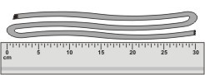

The ribbon is around

A. 10 cm long.

B. 30 cm long.

**C. 90 cm long.**

D. We can't say. We need a longer scale to measure it.

4. The costs of 3 different chocolate bars are shown in this table.

|  |  |
| --- | --- |
| **CHOCOLATE** | **COST PER BAR** |
| CRUNCH BAR | Rs. 11 |
| FRUIT BAR | Rs. 13 |
| NUT BAR | Rs. 22 |

Lata bought 4 NUT bars.For the same amount of money, how many CRUNCH bars could she have

bought?

A. 11

**B. 8**

C. 4

D. 2'

5. Sheel counted the number of flowers in her garden. She made the following chart.

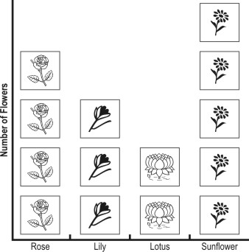

Sheel's mother asked her to bring 3 flowers from the garden. She told Sheel that it could be any flower but all 3 flowers must be of the same type. Which flowers can Sheel bring?

A. only lily

B. only lotus

C. either lily or rose

**D. any of lily, rose or sunflower**

6. Given below is a list of TV programs that Romy would like to watch on a day.

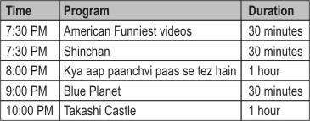

Romy is allowed to watch TV for AT MOST 1 HOUR (all programs together). He wants to watch 2 programs. Which two programs can he watch completely?

**A. Shinchan and Blue Planet**

B. Shinchan and Kya aap paanchvi paas se tez hain

C. Blue Planet and Takashi Castle

D. American Funniest videos and Takashi Castle

7. This is the score-card of a recent India-Sri Lanka One Day International cricket match. Study it carefully and answer the question that follows.

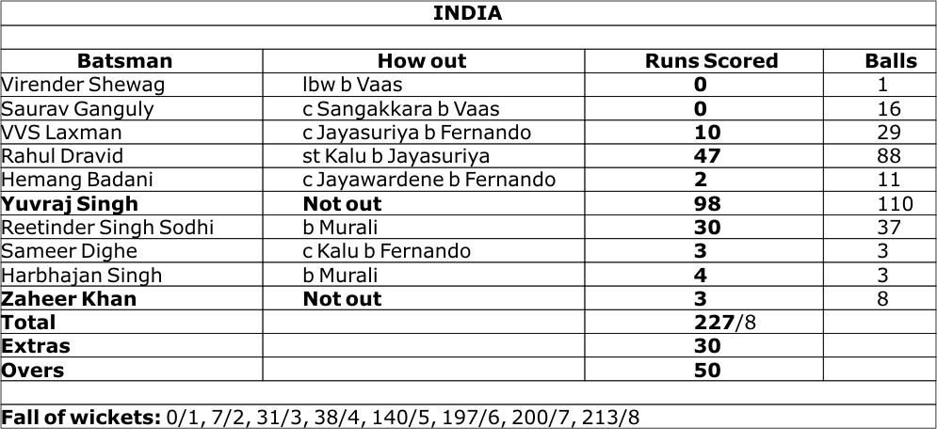

The total runs scored by the first 5 batsmen was:

A. 49

**B. 59**

C. 57

D. 145

8. A number is missing in the addition problem below.

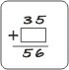

What will you do to find the missing number in the  ?

A. 35 + 56

**B. 56 - 35**

C. 56 + 35

D. 35 - 56

9. A number is subtracted from 264. The answer is LESS THAN 100.

Which of these could be the number?

A. 83

B. 160

C. 164

**D. 177**

10. 500 - 46 gives the same answer as 400 + ?

A. 46

**B. 54**

C. 64

D. 146

11. 220 + 380 = + 400 What should come in the blank above to make the number sentence true?

**A. 200**

B. 380

C. 600

D. 1000

12. Which of the following would give the same answer as 18 - 5?

A. 13 + 5

**B. 21 - 8**

C. 18 - 3

D. 21 - 3



**Maths**

1. D: Can you see the key of the pictograph? What does it say? Each plant shown stands for 4 saplings. There are 16 plants shown in the chart. Each of these stands for 4 saplings. So the total number of saplings planted by the five children is 16 x 4 = 64.

2. A: What is the distance between 3 cm mark and the 4 cm mark on the scale? 1 cm right, and not 4 cm? The length of the chalk stick is the same as the length between the 3 cm mark and the 8 cm mark. This length is 5 cm as shown in the figure.

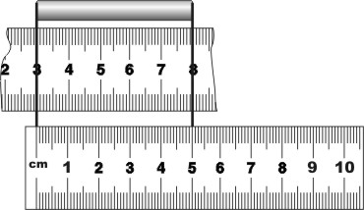

3. C: There are 3 folds of the ribbon. Each fold is about 30 cm long. So the total length of the ribbon is about 90 cm.

4. B: A Nut Bar costs Rs. 22. So 4 Nut Bars will cost Rs. 22 x 4 = Rs. 88. One Crunch Bar costs Rs. 11. So Lata can buy

88 ÷ 11, that is 8 Crunch Bars with Rs. 88. The question does not ask for the price of a Crunch Bar.

5. D: From the chart it can be seen that there were 4 roses, 3 lilies and 5 sunflowers in Sheel's garden. Sheel has to bring 3 flowers of the same type from the garden. So she can take 3 of the 4 roses or 3 of the 5 sunflowers or 3 lilies. So D is the answer and not A.

6. A: Romy is allowed to watch TV for not more than an hour. He wants to watch 2 programs completely. "Kya aap paanchvi pass se tez hain" and "Takeshi Castle" are 1 hour long programs. So he cannot watch either of these, along with some other program. So none of B, C and D can be the answer. Each of the two programs "Shinchan" and "Blue Planet" is 30 minutes long. So he can watch them completely.

7. B: Let us read the runs scored by the first 5 batsmen from the table. The first five batsmen have scored 0, 0, 10, 47 and 2 runs respectively. So the total runs scored by them is 0 + 0 + 10 + 47 + 2 = 59 runs.

8. B: 35 added to a number gives 56. What must you add to 35 to get 56? Try a simpler problem. What must you add to 4 to get 9? 5 right? That is the difference between 9 and 4. Similarly we must add the difference between 56 and 35 to 35 to get 56. That is we must add 56 - 35.

9. D: I have 264 marbles. I give you some marbles. Now I have less than 100 marbles. So how many marbles would I have given you? I should have given you more than 164 marbles so that I have less than 100 left with me. Of the given options, only 177 is greater than 164. If I give you just 83 marbles, I would still have 264 - 83 = 181 marbles with me. 181 is not less than 100.

10. B: 500 - 46 = 454. This is the same as 400 + 54. So option B is the correct answer. Note that the question asks for 500 - 46 and not 500 + 46. 400 + 146 = 546 which is 500 + 46.

11. A: The equal sign means that the numbers on both it's sides are equal, or the problems on both it's sides have the same answer. Here on the left side of the equal sign we have 220 + 380, that is 600. The problem on the right side also should have an answer 600. That is + 400 = 600. So what number should come in the blank? 600 - 400 = 200. If there is a blank soon after the equal sign, it does not mean that you have to write the answer to the problem that is there just before the equal sign in the blank.

12. B: 18 - 5 = 13. Which of the given problems, gives an answer, 13? 21 - 8 = 13. So the answer is option B. 13 + 5 = 18, 18 - 3 = 15 and 21 - 3 = 18. So none of the other problems give 13 as the answer. Note that option A is not just 13, but 13 + 5.